
[PPJP-53] Verify that the email field accepts a valid email address format Created: 23/Aug/24 Updated: 23/Aug/24
Status: | To Do
Project: | Paws Paradise-Jira project

Type: | Bug | Priority: | Medium
Reporter: | Tomer Darmon | Assignee: | Unassigned
Environment: | Google Chrome  Version 124.0.6367.202 (Official version) (64 bit)  Microsoft Edge  Version 124.0.2478.97 (Official build) (64-bit)

Attachments: | 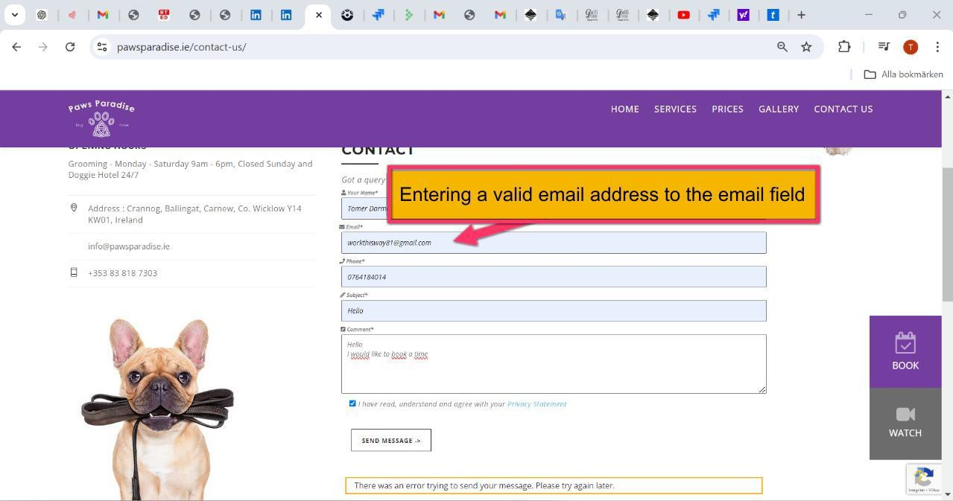
Severity1: | S3-Major

Description
Steps to Reproduce :
- Ente the website: https://www.pawsparadise.ie/contact-us/
- Scroll down the page to the "Email" field
- Enter a valid email address: workthisway81@gmail.com
- Fill in all the fields and submitted the form
Actual Result :
The email field doesn´t accept a valid email address as we get error notification at the bottom of the page.
Expected Result :
I will expect that since the email address is valid, the form will be submitted after filling up all the other fields

72

